**Lab Exercise 4– Terraform Variables**

Define Variables:

• Open a new file named variables.tf. Define variables for region, ami, and instance type.

# variables.tf

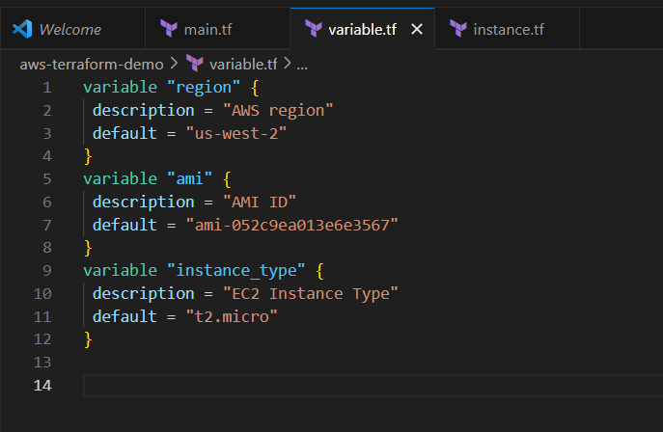

Use Variables in main.tf:

• Modify main.tf to use the variables. # main.tf

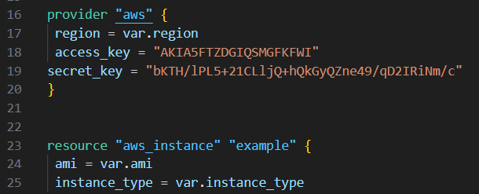

Initialize and Apply: • Run the following Terraform commands to initialize and apply the configuration.

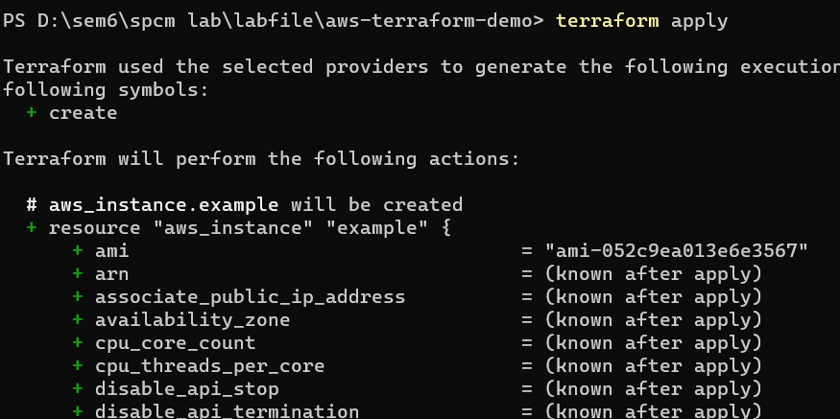

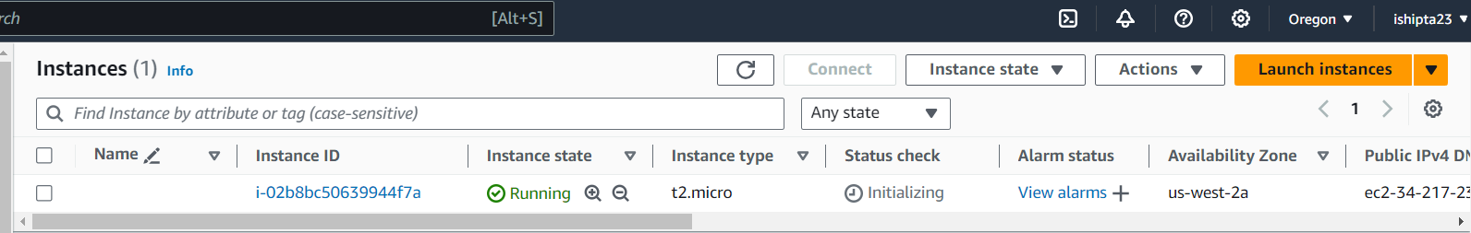

. Clean Up:

After testing, you can clean up resources.

